**Performance Task Document**

First task: You are a …………… (Math, Arabic, English,…) teacher for a class that has many individual differences in terms of "interests, readiness, multiple intelligence and learning styles". At the beginning of the school year, you entered the classroom and wanted to provide a preventive framework for learners to reduce the risk of academic failure. Therefore, you prepared revision activity sheets for the essential competencies in terms of cognition and skills that enable learners to start learning the curriculum objectives of the current class. After the revision, you conducted a diagnostic evaluation. And at the end of the first month, you filled out Mounir's achievement screening tool.

After reading carefully, analyze the pattern of academic difficulties and their reasons:

|  |  |  |  |  |
| --- | --- | --- | --- | --- |
| Towards acquiring comprehension skill: | | | | |
| The learner masters the language to the required level if: | Acquired | In Acquisition | Not acquired | Observations |
| Executes verbal instructions accurately, during an activity. | X |  |  |  |
| Answers questions to an age-appropriate audio document (about a minute). | X |  |  |  |
| Towards acquiring the skill of oral expression: | | | | |
| Retells, in simple sentences, a story he heard or describes a scene he saw in an appropriate language, recalling the elements of the text in his own style.  Or expresses his ideas using simple sentences, based on a visual document or audio text or a daily event that he has lived or heard about. |  | X |  |  |
| Towards acquiring reading skill and reading comprehension: | | | | |
| In understanding the printed documents: |  |  |  |  |
| Distinguishes:  ✔ the cover  ✔ the address  ✔ the writer  ✔ the painter  ✔ the beginning of a page  ✔ the end of a page  ✔ the first word on the page  ✔ the last word in the paragraph  ✔ the letters in a word  ✔ the stop signs  ✔ the long vowel in the word  ✔ the short vowel in the word | X  X  X  X  X  X  X  X | X | X  X  X |  |
| In aloud reading: | | | | |
| Distinguishes sounds:  ✔ At the beginning, middle, and end of a word. |  |  | X |  |
| Reads two sentences fluently in an expressive intonation:  ✔ Pronounces long and short sounds.  ✔ Pronounces the letters correctly.  ✔ Reads the short vowels correctly. |  | X | X  X | If it is connected to a letter he knows  Some of them: **د- ر- ف – س – ب - ح** |
| In reading comprehension: | | | | |
| Answers questions related to the content of the text. |  | X |  |  |
| Towards acquiring the skill of written expression: | | | | |
| Copies a sentence in a clear handwriting, using calligraphy. |  | X |  |  |
| Arranges letters to build words. |  |  | X |  |
| Writes dictated sentences correctly. |  |  | X |  |
| Gradually expresses topics appropriate to his inclinations and desires:  ✔ Builds a simple sentence.  ✔ Composes a sentence based on pictures. |  |  | X  X |  |
| Uses the full stop appropriately. |  |  | X |  |

Analysis and reasons:

---------------------------------------------------------------------------------------------------------------------------------------------------------------------------------------------------------------------------------------------------------------------------------------------------------------------------------------------------------------------------------------------------------------------------------------------------------------------------------------------------------------------------------------------------------------------------------------------------------------------------------------------------------------------------------------------------------------------------------------------------------------------------------------------------------------------------------------------------------------------------------------------------------------------------------------------------------------------------------------------------------------------------------------------------------------------------------------------------------------------------------------------------------------------------------------------------------------------------------------------------------------------------------------------------------------------------------------------------------------------------------------------------------------------------------------------------------------------------------------------------------------------------------------------------------------------------------------------------------------------------------------------------------------------------------------------------------------------------------------------------------------------------------------------------------------------

---------------------------------------------------------------------------------------------------------------------------------------------------------------

Second task:

After you have determined Mounir's academic level, you have to prepare a "comprehension of Text" activity for your classroom using differentiated instruction taking into consideration Mounir's level and using the techniques below and filling the activities in the following table. P.S: Don't forget to determine Mounir's academic level and to put him in the right group.

Evidence-based intervention is used within the methods assigned to the learning process

**Vocabulary construction**

**Understanding the reading text**

click or clunk

**Enhance fluency in reading**

**Reading sight words**

**Cover, Copy, & Compare (CCC) Math Facts**

|  |  |  |  |
| --- | --- | --- | --- |
|  | Group 1 | Group 2 | Group 3 |
| Description of the group and its capabilities |  |  |  |
| Content |  |  |  |
| Educational process |  |  |  |
| Outcome |  |  |  |

Third task:

It's been 12 weeks since your Tier 1 intervention and it's time to fill out Mounir's Skills Screening tools.

Reading skills (in Arabic and foreign languages)

|  |  |  |  |
| --- | --- | --- | --- |
|  | Acquired | Not acquired | Observations |
| 1. Understands an audible text (we read it to him). | X |  |  |
| 2. Executes more than one instruction at the same time (2 and above). | X |  |  |
| 3. Maintain his attention and concentration even in the absence of visual aids. |  | X | Not for enough time |
| 4. Perceives rhymes and divides words into syllables. |  | X | In simple words: example: درس |
| 5. Identifies the sounds in the words (verbally). |  | X | Sometimes and hesitantly |
| 6. Connects letters to sounds (at least one sound for each letter). |  | X | Not all the letters |
| 7. Recognizes all forms of letters when reading (in Arabic, for example: م - ــم – مـ - ــمـ). |  | X |  |
| 8. Recognizes all characters according to the used font (in foreign language, script and cursive). |  | X |  |
| 9. Recognize all foreign language letters: capital and small letters. |  | X |  |
| 10. Proficient in spelling: Can combine letters to read words he does not know. |  | X |  |
| 11. Reads according to the sequence of letters in the word. | X |  | In words he only knows |
| 12. Can read sight words and frequent words globally. | X |  |  |
| 13. Has a smooth and fluent reading: Reads without hesitation or returning back. |  | X |  |
| 14. Manages to finish educational activities that depend on reading. |  | X |  |
| 15. Understands a text from his class level. |  | X |  |
| 16. Has the same efficiency in understanding an audible text and a text he red. |  | X |  |

After you analyze the checklist content, determine the type of intervention needed in terms of:

1. Level/Tier: ----------------------------------------------------------------------------------------------------------------------------------------
2. Number of learners in a group: -------------------------------------------------------------------------------------------------------------
3. Number of sessions per week: --------------------------------------------------------------------------------------------------------------
4. Intervention strategies adopted for the second Tier: ---------------------------------------------------------------------------------------------------------------------------------------------------------------------------------------------------------------------------------------------------------------------------------------------------------------------------------------------------------------------------------------------------------------------------------------------------------------------------------------------------------------------------------------------------------------------------------------------------------------------------------------------------------------------------------------------------------------------------------------------------------------------------------------------------------------------------------------------------------------------------------------------------------------------------------------------------------------------------------------------------------------------------

Fourth task:

Although the intervention turned into small groups, Mounir did not benefit much. So you transferred his cumulative file to the specialized team. After conducting the official tests, the results were as follows:

IQ test: overall average of 100, difficulties in visuo-spatial analysis, attention and auditory memory. Good abilities in oral language comprehension and logical analysis

Speech and language test: difficulty in recognizing different letters, lack of acquisition of analytical strategy in reading and writing, depends on global reading, has a difficulty in phonological awareness.

Psychomotor testing: difficulties in attention, difficulties in problem solving, difficulties in visuo-spatial structure and in visual analysis of directions.

After reviewing the content of the results, please contribute to writing an individual educational plan (IEP) for Mounir.

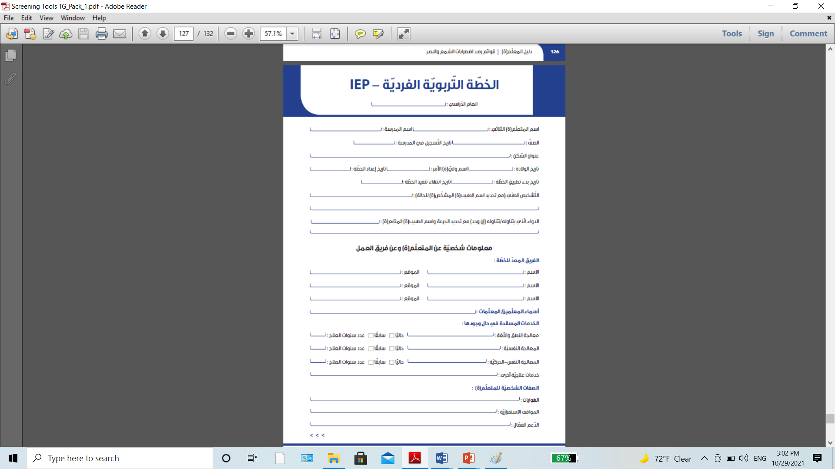

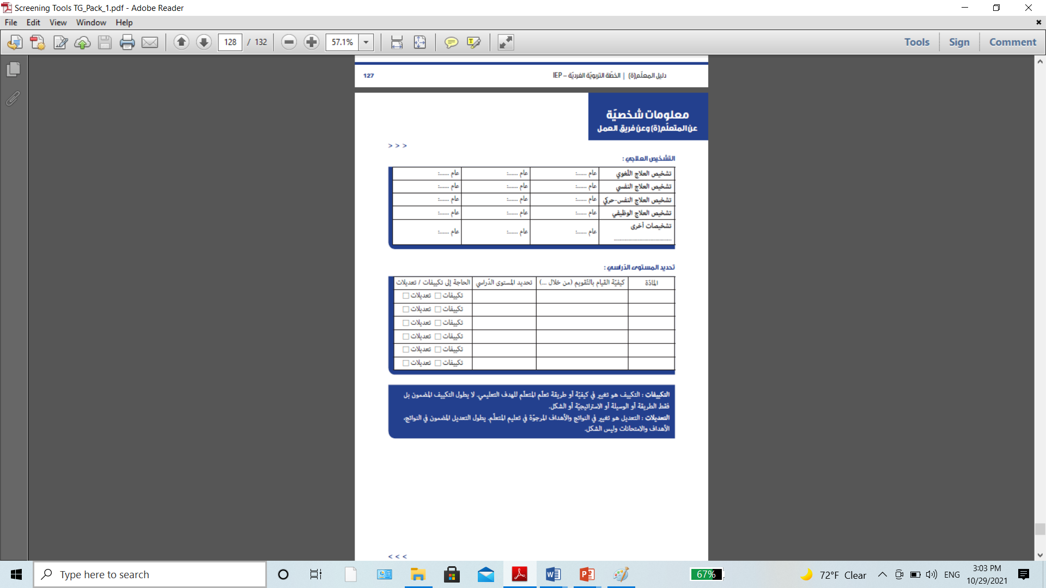

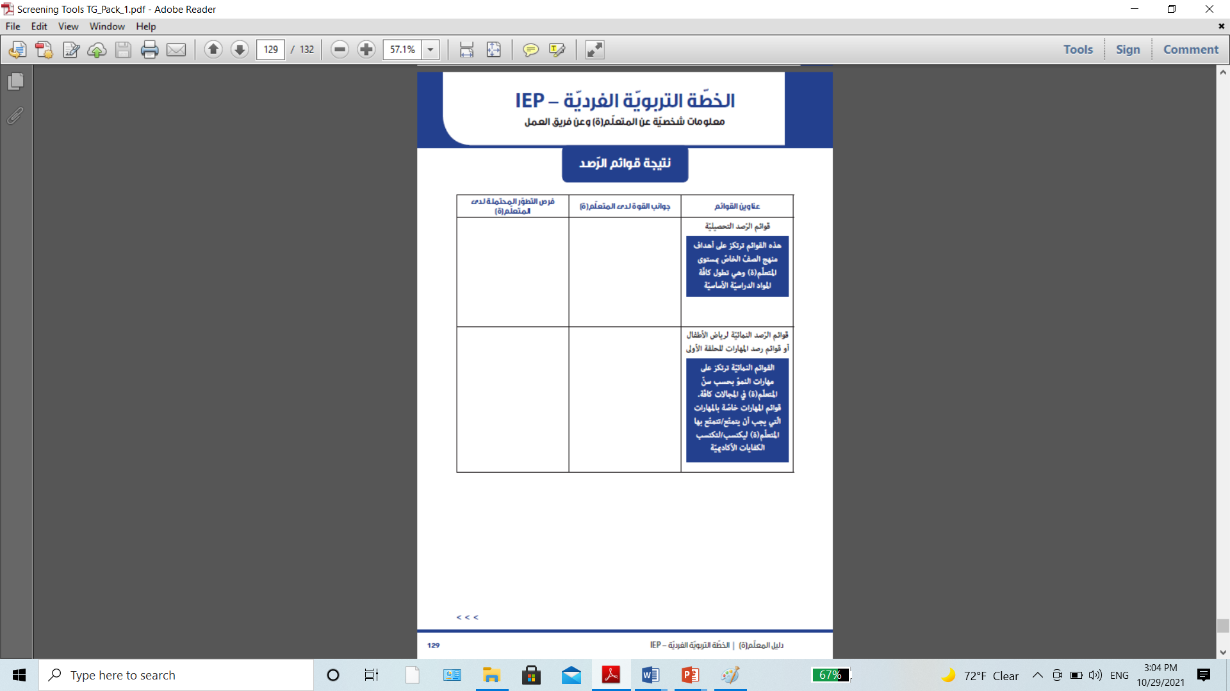

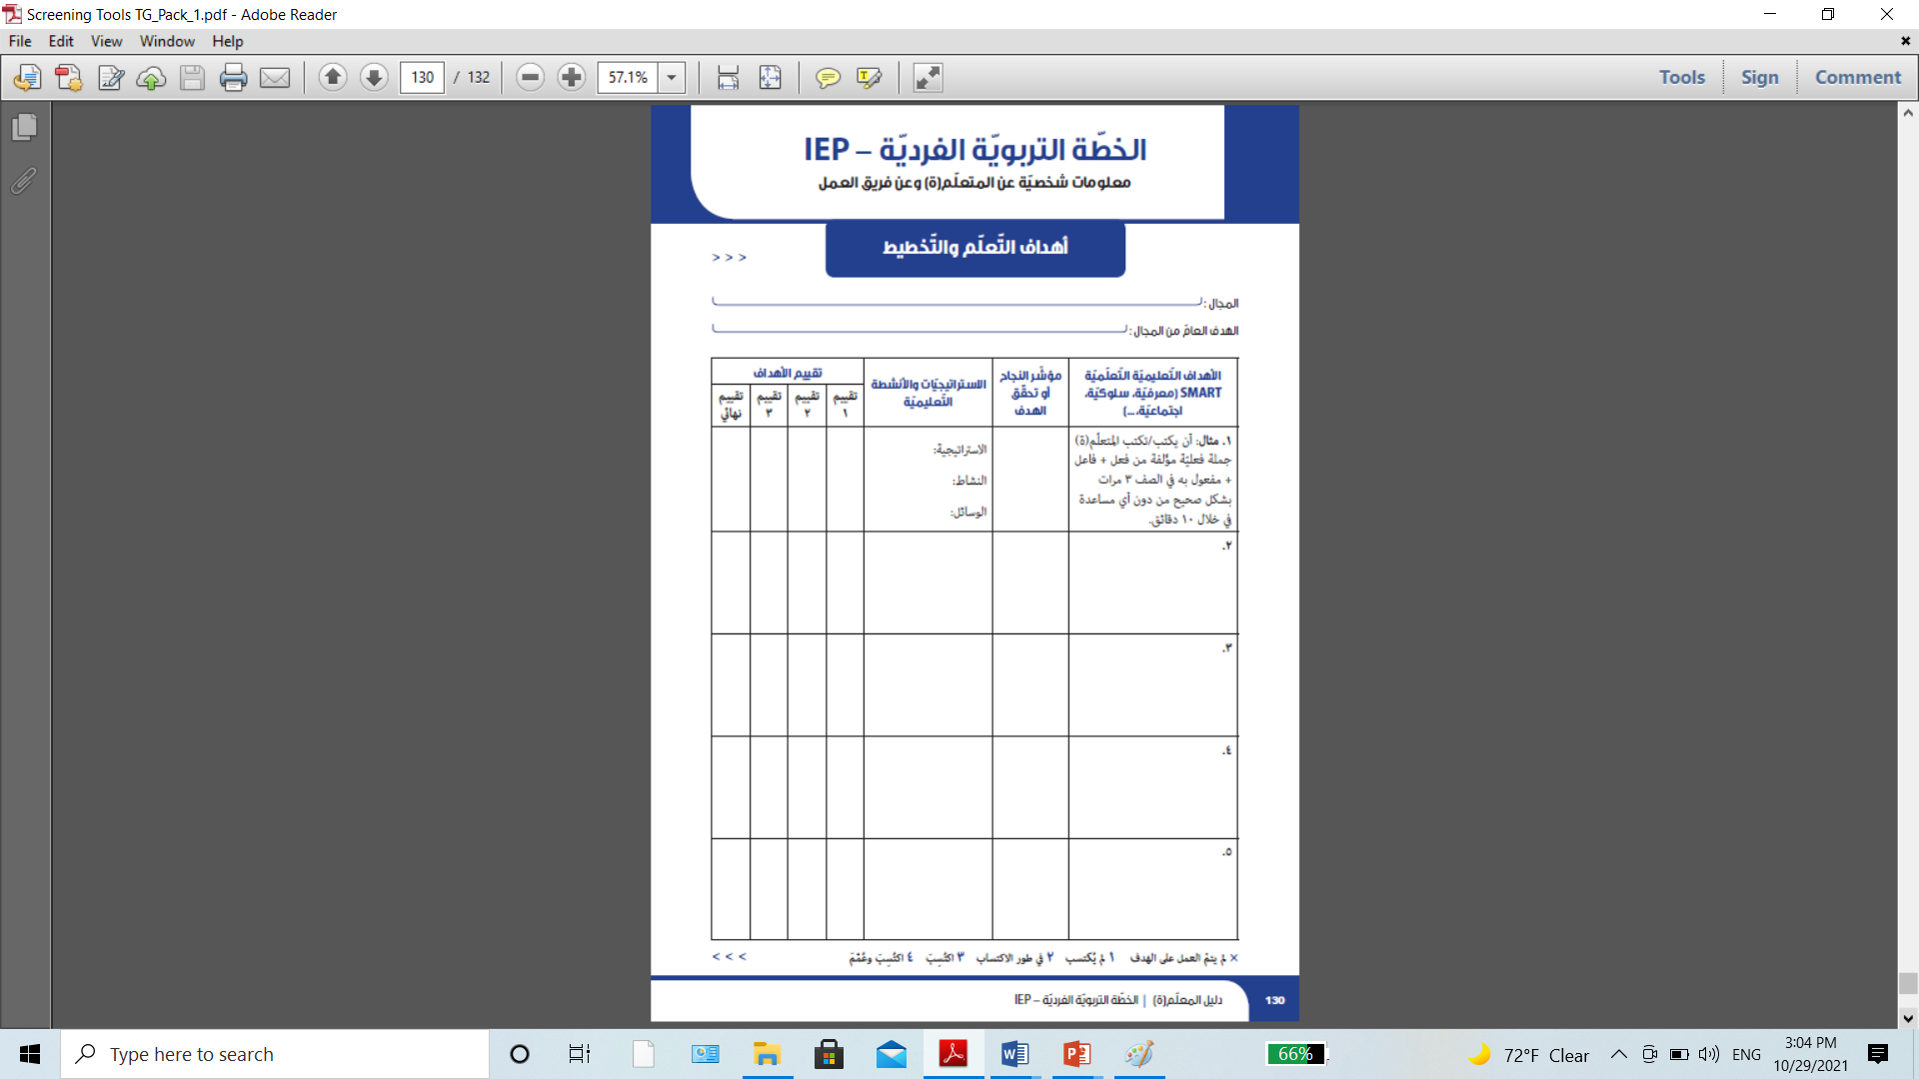

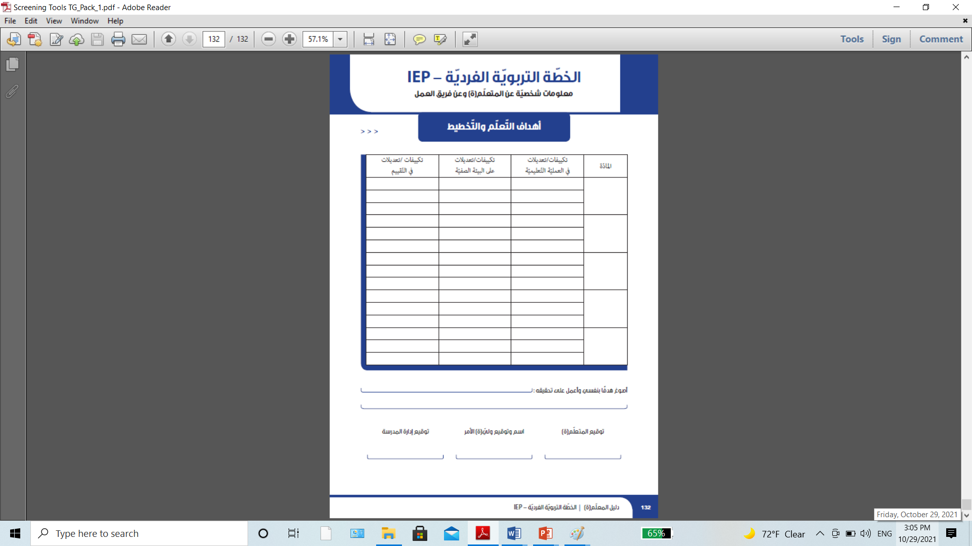

What attitudes would you embrace to succeed in your work in this class and why? List any expected challenges and how would you overcome them.

…………………………………………………………………………………………………………………………………………………………………………………………………………………..………………………………………………………………………………………………………………………………………………………………………………………………………………….………………………………………………………………………………………………………………………………………………………………………………………………………………….………………………………………………………………………………………………………………………………………………………………………………………………………………….………………………………………………………………………………………………………………………………………………………………………………………………………………….………………………………………………………………………………………………………………………………………………………………………………………………………………….………………………………………………………………………………………………………………………………………………………………………………………………………………….……………………………………………………………………………………………………………………………………………………………………………………………………………

Name of the author of the intervention plan

**Rubric of evaluation**

Inclusion: This model is used by trainers to evaluate participants' performance. It is also used by participants to guide them into the implementation process and performance task.

|  |  |  |  |
| --- | --- | --- | --- |
| First task: error analysis | | | |
|  | 1 (unacquired) | 2 (in the process of acquisition) | 3 (acquired) |
| Analysis of achievement screening tools errors | did not know how to link performance to reasons | Linked the difficulties to reading disorder only | Linked the difficulties to:  - Reading disorder  - Hearing impairment  - Poor learning  - Attention and memory difficulties  - Difficulties in visual discrimination |
| Second task: differentiation of activity | | | |
|  | 1 (unacquired) | 2 (in the process of acquisition) | 3 (acquired) |
| Content | Didn’t differentiate the content | Chose a differentiation strategy but wasn’t adequate to the level, it was limited to diversifying resources | Chose gradient or progressive content |
| Educational process | Didn’t differentiate the educational process | Used graphs only to understand the text | Used evidence-based intervention strategies: reading sight words, reading fluently |
| Outcome | Didn’t differentiate the outcome | Chose one strategy for the three groups | Chose the right strategy for each group |
| Task Three: Tier 2 Strategies | | | |
|  | 1 (unacquired) | 2 (in the process of acquisition) | 3 (acquired) |
| Appropriate strategies for obstacles | Didn't choose any strategy | Only chose strategies for reading | Chose strategies for reading and text comprehension |
| Fourth task: writing the individual educational plan | | | |
|  | 1 (unacquired) | 2 (in the process of acquisition) | 3 (acquired) |
| Individual plan (required parts from the teacher) | Didn’t know how to fill the plan | Filled in half of the required information | Filled it all with correct answers |